Assembling Air Brake

# Parts

The nose cone and air brake assembly consist of several parts.

* Electronics raft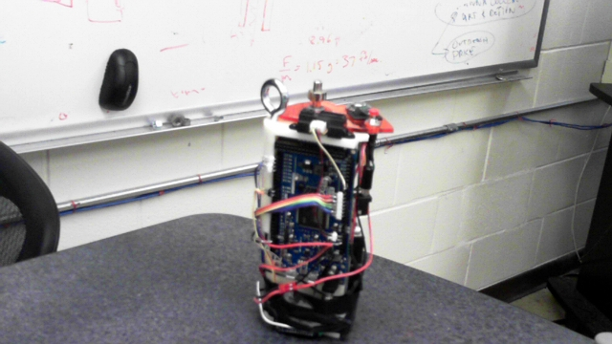 The electronics are mounted on a triangular prism with three mounting holes on the bottom. On the top of the raft are the motor controls, an eyebolt, and a small catch on the end of the motor shaft.
* Rear bulkhead tube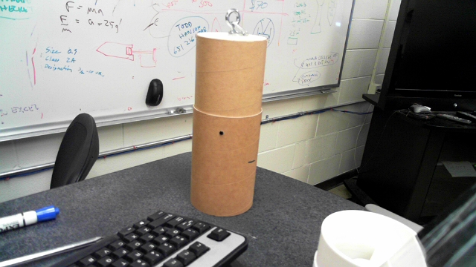 The electronics raft slides into the rear bulkhead tube and is secured to it by three bolts.
* Nose cone transition 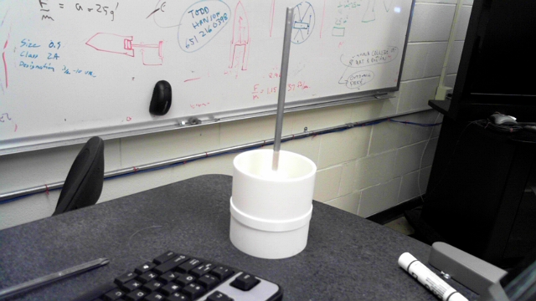The nose cone transition piece inserts inbetween the rear bulkhead tube and the nose cone tube. It also holds the rod that the air brake carriage slides on.
* Nose cone tube 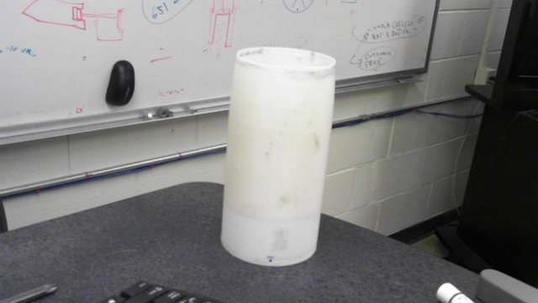The nose cone tube sits on the nose cone transition and over the air brake carriage.
* Air brake carriage 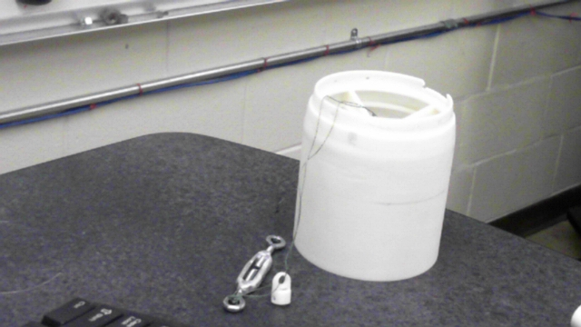The air brake carriage consist of three parts joined by string.
  + Main carriage - The nose cone is mounted on the main carriage.
  + Plastic tip – The plastic tip sits on top of the rod on the nose cone transition piece.
  + Turn buckle – The turn buckle is adjusted to tension the string
* Nose cone 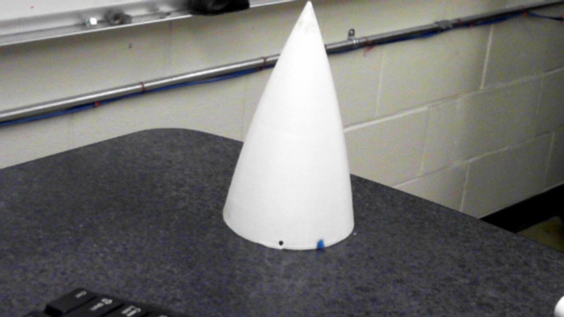The nose cone is bolted onto the air brake carriage.

# Assembly

1. Insert the electronics raft into the rear bulkhead tube. Make sure to align the tip of the electronic raft with the mark on the inside of the rear bulkhead tube.
2. Power on the electronics. Press the red motor jogging button to rotate the motor catch into the proper position. When the motor is positioned correctly hit the green arming button, the button should light up to indicate it is armed.
3. Unscrew the lower bolt of the turn buckle that connects to the motor catch.
4. Thread the loop through the eyebolt on the electronics raft and onto the motor catch. The string should be able to be pulled taught without slipping of the motor catch.
5. Slide the nose cone transition piece onto the rear bulkhead tube. The lower bolt of the turn buckle should now be coming up through the gaps in the nose cone transition.
6. While keeping the lower turn buckle bolt taught slide the air brake carriage over the rod on the nose cone transition and attach the plastic tip to the rod.
7. Lower the rest of the turn buckle through the air brake carriage and screw the lower bolt into the turn buckle. 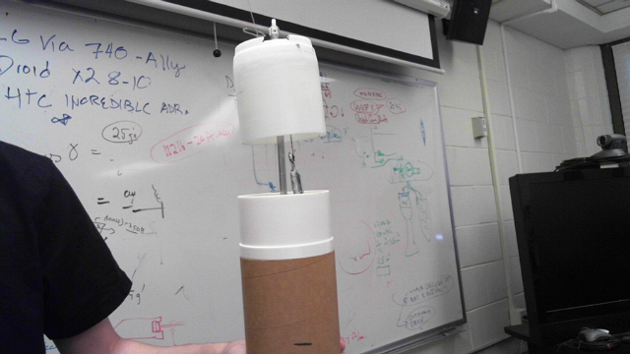
8. Tighten the turn buckle so that the air brake carriage sits at the desired height.
9. Lower the nose cone tube over the air brake carriage.
10. Bolt the nose cone tip onto the air brake carriage.